**FLIPKART SALES SQL QUERIES**

**A.KPI’S**

1. **Average Price:**

select avg(Price) from flipkart_products;



1. **Average Rating :**

select avg(Rating) from flipkart_products;



1. **Average Buyers:**

select avg(Buyers) from flipkart_products;



1. **Average Product Sold:**

select avg(Total_Sold) from flipkart_products;

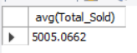

1. **Average Discount:**

select avg(`Discount(%)`) from flipkart_products;



**B. OTHER PARAMETERS:**

1. **Average Rating Per Category:**

select avg(Rating),Main_Category from flipkart_products group by Main_Category;

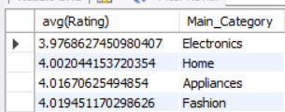

2. **Average Price Per Category:**

select avg(Price),Main_Category from flipkart_products group by Main_Category;

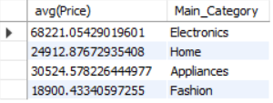

3. **Average Product Per Category:**

select count(Product_Name),Main_Category from flipkart_products group by Main_Category;

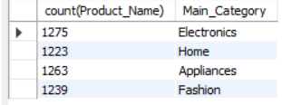

**4. Average Discount Per Category:**

select avg(`Discount(%)`),Main_Category from flipkart_products group by Main_Category;

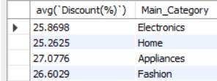

1. **Average Product Listed Per Seller:**

select count(Product_Name),Seller from flipkart_products group by Seller;

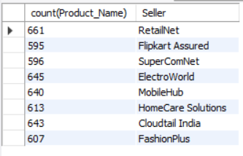

1. **Average Rating per Seller:**

select avg(Rating),Seller from flipkart_products group by Seller;

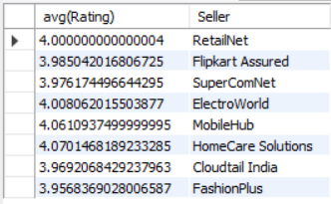

1. **Average Buyer Per Sub Category:**

select avg(Buyers),Sub_Category from flipkart_products group by Sub_Category;

